

*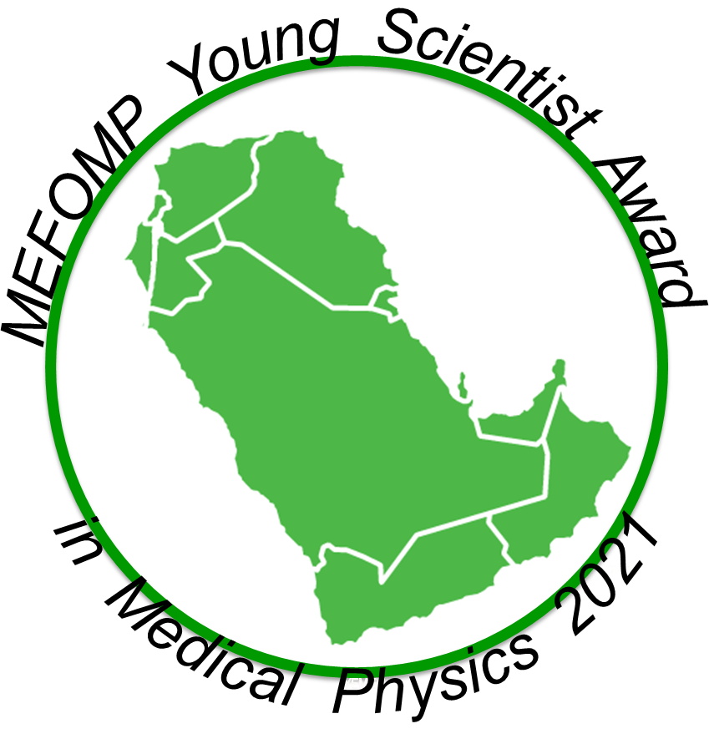*

*MEFOMP Young Scientist Award in Medical Physics 2021*

The Middle East Federation of Organizations of Medical Physics (MEFOMP) is pleased to announce the MEFOMP Young Scientist Award 2021.

**The Award will include a MEFOMP certificate and a short biography of the awardee will be published in MEFOMP website.**

**Criteria for selection:**

* The recipient of the award should be under 40 years of age on 31 Dec. 2021
* Minimum of MSc in medical physics
* The recipient has completed 5 years of research or development in medical physics.
* The recipient should have performed medical physics work of outstanding quality.
* The award may only be received one time by any individual.
* Nominee shall not be a current member of the MEFOMP Awards & Honors Committee or the MEFOMP Executive Committee.

**Nominating Procedure**

* The award will be advertised by **MEFOMP** on the organization’s website: <http://www.mefomp.com>
* Nominations must be made to the Chair of the MEFOMP Awards and Honors Committee (AHC) by MEFOMP National Member Organizations (NMO) or by individuals with the support of senior medical physicist.
* All nominations should include the following:

1. A supporting letter evaluating nominee’s achievements from by the National Member Organizations (NMO) or a senior medical physicist.
2. CV only 4 pages with all publications.

The closing date for nominations is noon (Arabian Standard Time) on 28th October 2021.  Nominations should be sent to Dr. Afkar AlFarsi at [afkar.alfarsi@gmail.com](mailto:afkar.alfarsi@gmail.com" \t "_blank) with a copy to Secretary General of MEFOMP Dr Mohammad Hassan Kharita at [mkharita@hamad.qa](mailto:mkharita@hamad.qa).

Submissions should be in the form of MS Word or PDF document.  Nominations will be acknowledged by e-mail. If you do not receive an acknowledgement within 72 hours please contact Dr Al Farsi and the Secretary General of MEFOMP.

The winner will be announced on Nov 7, 2021.